Cantina Castello Di Torre In Pietra
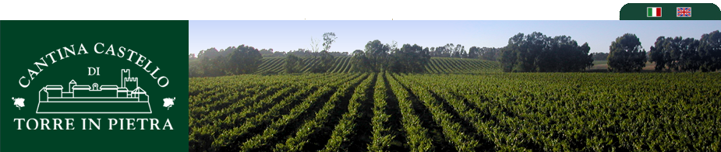
VINGÅRD UTANFÖR ROM – För vidare upplysningar om deras arrangemang kontakta Nygrens i Tingsryd.
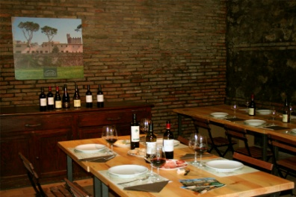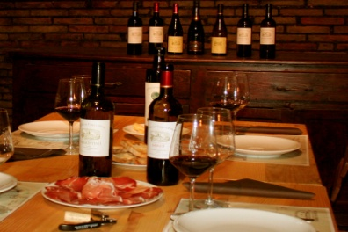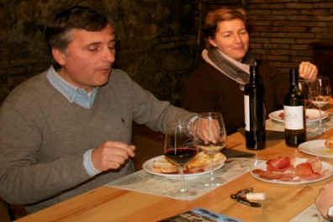
It is our pleasure to welcome you in person to the Cantina Castello di Torre in Pietra wine estate where you can taste, buy our products, visit the cellar and go for a walk on one of the wood's itineraries.
Cellar visit
Our tours begin with a stroll to the vineyards followed by a visit to the cellar. You will be briefly acquainted with the fermentation area, the wood-ageing room, the bottling and the bottle-ageing areas. During the visit we will talk about the territory, the wine estate and technical aspects of wine production.
Wine tasting
It is possible to taste our wines free without a visit to the cellar.
Group size: maximum of 40 persons.
Wine tasting opening hours are:
from Monday to Saturday 9.00-12.00 & 15.00 – 18.00
Wine shop
Our wines, grappa and extra virgin olive oil are also available for purchase directly at the cellar. Courier delivery is available within Italy.
All major credit cards are accepted.
Sales opening hours are:
from Monday to Saturday 8.30 – 12.30 & 14.30 – 18.30
Special events
Corporate luncheons, team-building events, and wedding aperitifs are just some of the special events that Torre in Pietra has hosted. Please contact us with your request and we will be happy to build a solution suitable to your needs.
Open House
Cantina Castello di Torre in Pietra hosts various open houses throughout the year. This is a way of thanking our customers for their continued trust in our wines. To be informed of the next open house or any of our public events such as Cantine Aperte please visit our Friends of the Cantina page and join our mailing list.1

